SECOND GRADE ENHANCED MATHEMATICS
UNIT 2 STANDARDS
Dear Parents,

We want to make sure that you have an understanding of the mathematics your child will be learning this year. Below you will find the standards we will be learning in Unit Two. Each standard is in bold print and underlined and below it is an explanation with student examples. Your child is not learning math the way we did when we were in school, so hopefully this will assist you when you help your child at home. Please let your teacher know if you have any questions. ☺

MGSE2.MD.1 Measure the length of an object by selecting and using appropriate tools such as rulers, yardsticks, meter sticks, and measuring tapes.
This standard calls for students to measure the length of objects in both customary (inches and feet) and metric (centimeters and meters). Students should have ample experiences choosing objects, identifying the appropriate tool and unit, and then measuring the object. The teacher should allow students to determine which tools and units to use.

Foundational understandings to help with measure concepts:
- Understand that larger units can be subdivided into equivalent units (partition).
- Understand that the same unit can be repeated to determine the measure (iteration).
- Understand the relationship between the size of a unit and the number of units needed (compensatory principle).
- Understand the measuring of two-dimensional space (area) using non-standard units.

MGSE2.MD.2 . Measure the length of an object twice, using length units of different measurements; describe how the two measurements relate to the size of the unit chosen. Understand the relative size of units in different systems of measurement. For example, an inch is longer than a centimeter. (Students are not expected to convert between systems of measurement.)
This standard calls for students to measure an object using two units of different lengths.

Example: A student measures the length of their desk and finds that it is 3 feet and 36 inches. Students should explore the idea that the length of the desk is larger in inches than in feet, since inches are smaller units than feet. This concept is referred to as the compensatory principle. Note: this standard does not specify whether the units have to be within the same system.

MGSE2.MD.3 Estimate lengths using units of inches, feet, centimeters, and meters.
This standard calls for students to estimate the lengths of objects using inches, feet, centimeters, and meters. Students should make estimates after seeing a benchmark unit, such as the length of one inch, before making their estimate.

Example: Look at your ruler to see how long one inch is. Now, estimate the length of this paper in inches.

MGSE2.MD.4 Measure to determine how much longer one object is than another, expressing the length difference in terms of a standard length unit.
This standard calls for students to determine the difference in length between two objects. Students should choose objects, identify appropriate tools and units, measure both objects, and then determine the differences in lengths.

MGSE2.MD.7 Tell and write time from analog and digital clocks to the nearest five minutes, using a.m.

and p.m.
This standard calls for students to tell (orally and in writing) and write time after reading analog and digital clocks. Time should be to 5 minute intervals, and students should also use the terms a.m. and p.m. Teachers should help students make the connection between skip counting by 5s and telling time on an analog clock.

MGSE2.MD.9 Generate measurement data by measuring lengths of several objects to the nearest whole unit, or by making repeated measurements of the same object. Show the measurements by making a line plot, where the horizontal scale is marked off in whole-number units.
This standard calls for students to represent the length of several objects by making a line plot. Students should round their lengths to the nearest whole unit.

Example: Measure objects in your desk to the nearest inch, display data collected on a line plot. How many objects measured 2 inches? 3 inches? Which length had the most number of objects? How do you know?
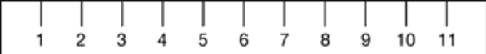

MGSE.3.MD.3 Draw a scaled picture graph and a scaled bar graph to represent a data set with several categories. Solve one- and two-step “how many more” and “how many less” problems using information presented in scaled bar graphs. For example, draw a bar graph in which each square in the bar graph might represent 5 pets.

This standard continues throughout the year.

Students should have opportunities reading and solving problems using scaled graphs before being asked to draw one. The following graphs all use five as the scale interval, but students should experience different intervals to further develop their understanding of scale graphs and number facts. While exploring data concepts, students should Pose a question, Collect data, Analyze data, and Interpret data (PCAI). Students should be graphing data that is relevant to their lives.
Example:
Pose a question: Student should come up with a question. What is the typical genre read in our class?
Collect and organize data: student survey
Pictographs: Scaled pictographs include symbols that represent multiple units. Below is an example of a pictograph with symbols that represent multiple units. Graphs should include a title, categories, category label, key, and data. How many more books did Juan read than Nancy?

Number of Books Read
Nancy
Juan
= 5 books

Single Bar Graphs: Students use both horizontal and vertical bar graphs. Bar graphs include a title, scale, scale label, categories, category label, and data.

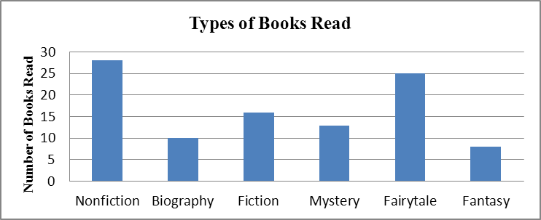

Analyze and Interpret data:
- How many more nonfiction books where read than fantasy books?
- Did more people read biography and mystery books or fiction and fantasy books?
- About how many books in all genres were read?
- Using the data from the graphs, what type of book was read more often than a mystery but less often than a fairytale?
- What interval was used for this scale?
- What can we say about types of books read? What is a typical type of book read?
- If you were to purchase a book for the class library which would be the best genre? Why?

Common Misconceptions
Although intervals on a bar graph are not in single units, students count each square as one. To avoid this error, have students include tick marks between each interval. Students should begin each scale with 0. They should think of skip- counting when determining the value of a bar since the scale is not in single units.

