Dear Parents:
SECOND GRADE ENHANCED MATHEMATICS
UNIT 3 STANDARDS

Below you will find the standards we will be learning in Unit Three. Each standard is in bold print and underlined and below it is an explanation with student examples. Your child is not learning math the way we did when we were in school, so hopefully this will assist you when you help your child at home. Please let your child’s teacher know if you have any questions. ☺

MGSE2.OA.1 Use addition and subtraction within 100 to solve one- and two-step word problems involving situations of adding to, taking from, putting together, taking apart, and comparing, with unknowns in all positions, e.g., by using drawings and equations with a symbol for the unknown number to represent the problem.

This standard calls for students to add and subtract numbers within 100 in the context of one and two step word problems. Students should have ample experiences working on various types of problems that have unknowns in all positions, including:

Addition Examples:

Result Unknown | Change Unknown | Start Unknown
There are 29 students on the playground. Then 18 more students showed up. How many students are there now?  (29 + 18 = ) | There are 29 students on the playground. Some more students show up. There are now 47 students. How many students came? (29 + = 47) | There are some students on the playground. Then 18 more students came. There are now 47 students. How many students were on the playground at the beginning? ( + 18 = 47)

This standard also calls for students to solve one- and two-step problems using drawings, objects and equations. Students can use place value blocks or hundreds charts, or create drawings of place value blocks or number lines to support their work. Two step-problems include situations where students have to add and subtract within the same problem.

Example:

In the morning there are 25 students in the cafeteria. 18 more students come in. After a few minutes, some students leave. If there are 14 students still in the cafeteria, how many students left the cafeteria? Write an equation for your problem.

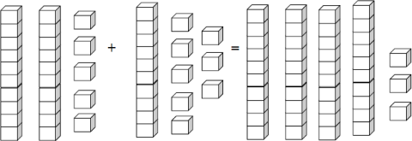
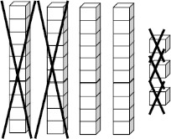
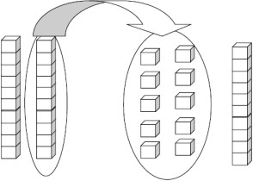
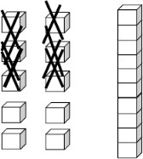
Student 1

Step 1 | I used place value blocks and made a group of 25 and a group of  18. When I counted them. I had 3 tens and 13 ones which is 43.
Step 2 | I then wanted to remove blocks until there were only 14 left. I removed blocks until there were 20 left.
Step 3 | Since I have two tens I need to trade a ten for 10 ones.
Step 4 | After I traded it, I removed blocks until there were only 14 remaining.
Step 5 | My answer was the number of blocks that I removed. I removed 2 tens and 9 ones. That’s 29.  My equation is 25 + 18 – = 14.

Student 2
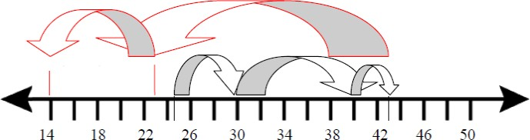
I used a number line. I started at 25 and needed to move up 18 spots so I started by moving up 5 spots to 30, and then 10 spots to 40, and then 3 more spots to 43. Then I had to move backwards until I got to 14 so I started by first moving back 20 spots until I got to 23. Then I moved to 14 which were an additional 9 places. I moved back a total of 29 spots. Therefore, there were a total of 29 students left in the cafeteria. My equation is 25 + 18 – = 14.

Student 3

Step 1 | I used a hundreds board. I started at 25. I moved down one row which is 10 more, then moved to the right 8 spots and landed on 43. This represented the 18 more students coming into the cafeteria. | 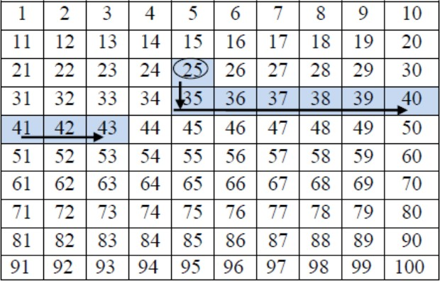
Step 2 | Now starting at 43, I know I have to get to the number 14 which represents the number of students left in the cafeteria so I moved up 2 rows to 23 which is 20 less. Then I moved to the left until I land on 14, which is 9 spaces. I moved back a total of 29 spots. That means 29 students left the cafeteria. | 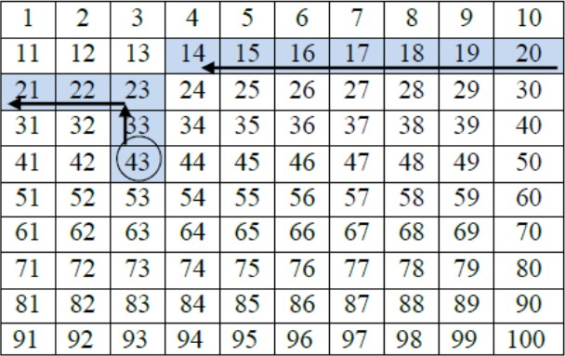
Step 3 | My equation to represent this situation is 25 + 18 – = 14.

MGSE2.NBT.5 Fluently add and subtract within 100 using strategies based on place value, properties of operations, and/or the relationship between addition and subtraction. This standard mentions the word fluently when students are adding and subtracting numbers within 100. Fluency means accuracy (correct answer), efficiency (basic facts computed within 4- 5 seconds), and flexibility (using strategies such as making 10 or breaking numbers apart).
This standard calls for students to use pictorial representations or strategies to find the solution. Students who are struggling may benefit from further work with concrete objects (e.g., place value blocks).
Example: 67 + 25 =

Place Value Strategy  I broke both 67 and 25 into tens and ones. 6 tens plus 2 tens equals 8 tens. Then I added the ones. 7 ones plus 5 ones equals 12 ones. I then combined my tens and ones. 8 tens plus 12 ones equals 92. |  | Counting On and Decomposing a Number Leading to Ten  I wanted to start with 67 and then break 25 apart. I started with 67 and counted on to my next ten. 67 plus 3 gets me to  70. Then I added 2 more to get to 72. I then added my 20 and got to 92. |  | Commutative Property I broke 67 and 25 into tens and ones so I had to add 60 + 7 + 20 + 5. I  added 60 and 20 first to get 80. Then I added 7 to get 87. Then I added 5 more. My answer is 92.

Example: 63 – 32 =
Relationship between Addition and Subtraction
I broke apart both 63 and 32 into tens and ones. I know that 2 plus 1 equals 3, so I have 1 left in the ones place. I know that 3 plus 3 equals 6, so I have a 3 in my tens place. My answer has a 1 in the ones place and 3 in the tens place, so my answer is 31.

MGSE2.MD.6 Represent whole numbers as lengths from 0 on a number line diagram with equally spaced points corresponding to the numbers 0, 1, 2, ..., and represent whole-number sums and differences within 100 on a number line diagram.
This standard calls for students to create number lines using numbers within 100 to solve addition and subtraction problems. Students should create the number line with evenly spaced points corresponding to the numbers.

MGSE2.MD.8 Solve word problems involving dollar bills, quarters, dimes, nickels, and pennies, using $ and ¢ symbols appropriately. Example: If you have 2 dimes and 3 pennies, how many cents do you have?

Example: If you have 2 dimes and 3 pennies, how many cents do you have? This standard calls for students to solve word problems involving either dollars or cents. Since students have not been introduced to decimals, problems should either have only dollars or only cents.
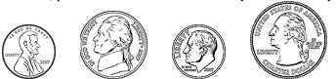
Example: What are some possible combinations of coins (pennies, nickels, dimes, and quarters) that equal 37 cents?
Example: What are some possible combinations of dollar bills ($1, $5 and $10) that equal 12 dollars?
It is suggested that money be taught daily through the daily math maintenance routine. For more information, please refer to pages 34-37 of the Second Grade Curriculum Overview.
Further information on teaching coin values: http://www.kentuckymathematics.org/docs/PIMSERMoney- teaching%20the%20value%20of%20coins.pdf
Develop an understanding of equivalency using resources such as: Coins for Unitary Thinkers- downloadable visual/mats http://ccgpsmathematicsk-5.wikispaces.com/1st+Grade Although this resource is located on the 1st grade page of the wiki, it is useful in 2nd grade as well.

MGSE2.MD.5 Use addition and subtraction within 100 to solve word problems involving lengths that are given in the same units, e.g., by using drawings (such as drawings of rulers) and equations with a symbol for the unknown number to represent the problem.
This standard applies the concept of length to solve addition and subtraction word problems with numbers within 100. Students should use the same unit in these problems.

Example: In P.E. class Kate jumped 14 inches. Mary jumped 23 inches. How much farther did Mary jump than Kate? Write an equation and then solve the problem.

Student 1  My equation is 14 + = 23 since I am trying to find out the difference between Kate and Mary’s jumps. I used place value blocks and counted out 14. Then I added blocks until I got to 23. I needed to add 9 blocks. Mary jumped 9 more inches than Kate. |  | 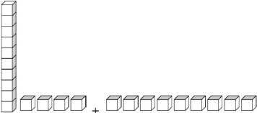
Student 2  My equation is 23 – 14 = . I drew a number line. I started at 23. I moved back to 14 and counted how far I moved. I moved back 9 spots. Mary jumped 9 more inches than Kate. | 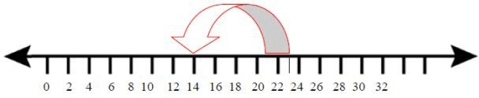

MGSE.3.MD.3 Draw a scaled picture graph and a scaled bar graph to represent a data set with several categories. Solve one- and two-step “how many more” and “how many less” problems using information presented in scaled bar graphs. For example, draw a bar graph in which each square in the bar graph might represent 5 pets.

This standard continues throughout the year.

Students should have opportunities reading and solving problems using scaled graphs before being asked to draw one. The following graphs all use five as the scale interval, but students should experience different intervals to further develop their understanding of scale graphs and number facts. While exploring data concepts, students should Pose a question, Collect data, Analyze data, and Interpret data (PCAI). Students should be graphing data that is relevant to their lives.
Example:
Pose a question: Student should come up with a question. What is the typical genre read in our class?
Collect and organize data: student survey
Pictographs: Scaled pictographs include symbols that represent multiple units. Below is an example of a pictograph with symbols that represent multiple units. Graphs should include a title, categories, category label, key, and data. How many more books did Juan read than Nancy?

Number of Books Read
Nancy
Juan
= 5 books

Single Bar Graphs: Students use both horizontal and vertical bar graphs. Bar graphs include a title, scale, scale label, categories, category label, and data.

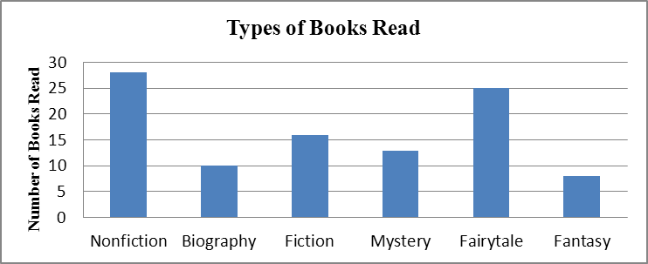

Analyze and Interpret data:
- How many more nonfiction books where read than fantasy books?
- Did more people read biography and mystery books or fiction and fantasy books?
- About how many books in all genres were read?
- Using the data from the graphs, what type of book was read more often than a mystery but less often than a fairytale?
- What interval was used for this scale?
- What can we say about types of books read? What is a typical type of book read?
- If you were to purchase a book for the class library which would be the best genre? Why?

Common Misconceptions
Although intervals on a bar graph are not in single units, students count each square as one. To avoid this error, have students include tick marks between each interval. Students should begin each scale with 0. They should think of skip- counting when determining the value of a bar since the scale is not in single units.

